Q1:

Step1: define a class flower and use initializer to set the default values of the 3 instance variables.

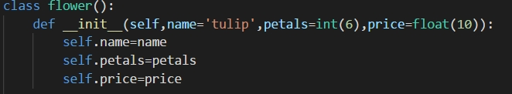

Step2: update_name method is to ask the user to input the name of the flower:

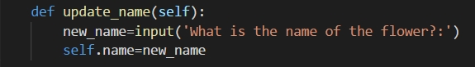

Step3: update_petals method is to ask the user to input the number of petals of the flower. It can check whether the input is in correct format. If not, it can ask the user to input again.

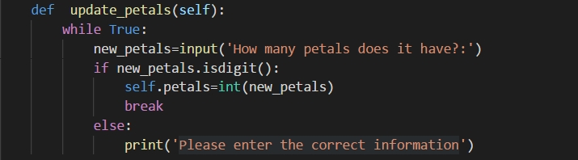

Step4: update_price method is to ask the user to input the price of the flower. It can check whether the input is in correct format. If not, it can ask the user to input again.

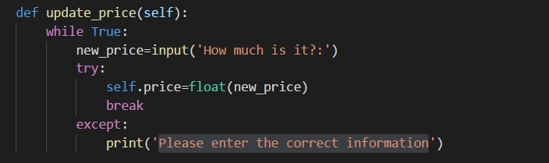

Step5: def main() function to put all these together and print out the result.

